**Mid-Course Student Feedback from GA Course\***

Activity File for Unit 2, How Adults Learn, Project

*\*Taken from actual student survey data; names have been changed.*

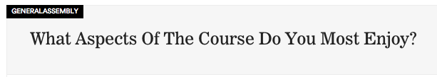

* Cooperative learning, real world examples — Raymond J.
* I enjoy being in class and the combination of lectures and activities - never stop the activities! Everything just feels so relevant.— Arielle S.
* In-class exercise — Hang L.
* being in a class with others. I haven't done it in ages — Todd M.
* The in-class exercises. They are practical and enable practice in real time — Anonymous
* Everything! It has been a very different experience from 'formal' college continue education programs, very enjoyable and worth my time and effort — Roberta W.
* The environment - being surrounded by people, students and those at GA, who are so enthusiastic and talented about digital. I'm out of time now...— Tien B.
* Getting to know other people and be exposed to other peoples professional backgrounds has been great. I really enjoy that [instructor name] has a retail background as it is much easier for me to relate to. — Bukky A.
* My favorite part are the in-class lessons where we work together. I think they're a valuable part of the process as they help us put what we've learned to work and also get to know our classmates in order to collaborate and learn from them. — Jeanny N.
* listening— Sergei P.
* I like that Kim is able to tie in real-life examples to the content we’re learning. It makes the class seem much more relevant. I really enjoyed the mid-course lab because it taught us to think outside of the box while doing some actual data analysis. — Anonymous
* the live examples and anecdotes of some of the successes and difficulties faced when applying some of the concepts/strategies — Anonymous
* Absolutely LOVE the teacher -- truly only have amazing things to say about her / such a great, contagious energy — Anonymous

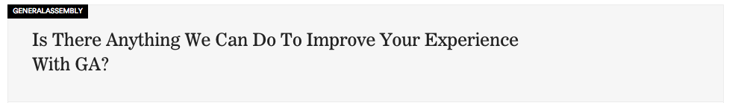

* By the looks of the syllabus, I feel the course could have gone 2 weeks longer to include a little more depth and mobile exposure — Raymond J.
* Perhaps more constructive criticism although it is always tough to swallow could really benefit a lot of us. — Anonymous
* Nada :) — Arielle
* maybe some game or ice-breaking activity on the first day of class?— Hang L.
* Make this an immersive course, with [instructor name] teaching it. — Sam E.
* I wish I could have attended more of the 1-session workshops at GA [that relate to this course] but so many are scheduled on the same night as our class (M&W).— Tien B.
* Make the pace of the class more clear upon signing up. Smaller class sections perhaps. Overall, I am very happy with the experience and learned tactics. Only hope is that more real world examples and case studies based will be used in the second half, leveraging the teacher's personal experiences. Coming into this class with marketing experience, in the second half of the class, I am hoping to get more engaging insider examples and tactics on how to think outside of the box to come up with complex digital marketing solutions. I’d also like to see the exercises we work through coupled with some sort of financial info to give context — Anonymous
* Upload powerpoints a day earlier rather than the day of; many of us have work during the day and its sometimes hard to print out materials. More time for mid-course project-1 week was not enough time for the project assignment. — Cassie C.
* no — Sergei
* More emphasis on career services and how we can apply and leverage skills in jobs we have now!— Anonymous
* more doing in class as opposed to going through slides? maybe what i desire is a lab and not a course — Anonymous
* More focus on data analytics — Anonymous